the barns hotel | cocksparrow lane | cannock | staffordshire | ws12 4pb
tel. 01543 469191 | fax. 01543 462552 | e info@thebarnshotel.co.uk
www.thebarnshotel.co.uk

Baby Showers

We have a variety of different options for your baby shower.

There are areas in our bar or restaurant where you can book a table and eat off one of our menus
Please note for parties of 12 or more we will need to organize one of our set menu’s for all of you party to choose off from the day

Midweek Tuesday –Friday £14.95 2 courses £18.95 3 courses

Tuesday to Saturday – Party Menu 2 Courses £18.95 3 Courses £22.95

Sunday Set Menu £18.95 3 course

We do have rooms, subject to availability for buffet parties
Function Room daytime (minimum 70) from £150
Restaurant daytime (minimum 30) from £100
Area in the bar – daytime (minimum 20) £50 to £100

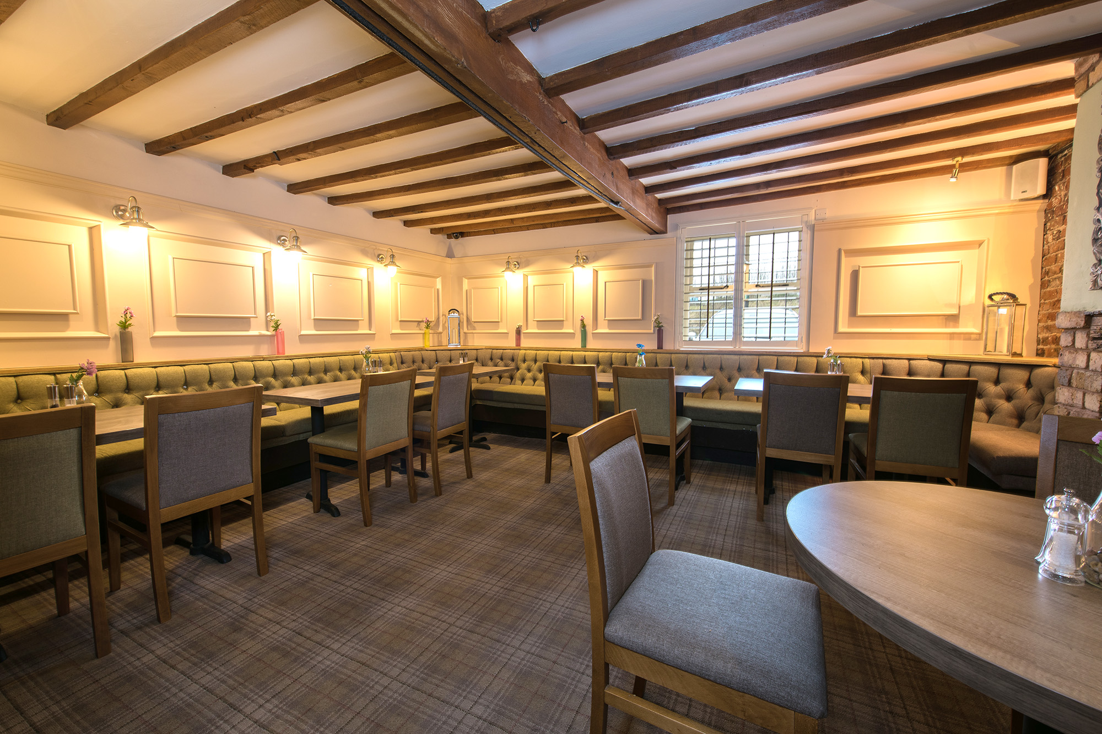
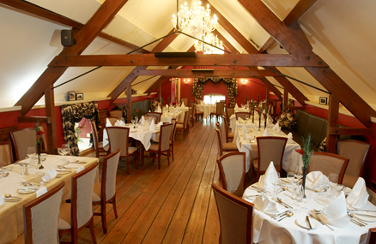

finger buffet £9.95

a selection of fresh sandwiches
homemade sausage rolls
Meditteranean vegetable quiche
traditional ascot pork pie
mini vegetable spring rolls
mini Indian samosas
marinated lamb skewers
mini savoury eggs
pickled onions, green salad
baby cherry tomatoes
sweet chilli sauce and tzatziki sauce

afternoon buffet £12.95

sandwiches to include
smoked salmon & cucumber,
egg mayo with watercress,
honey roast ham,
grated cheddar and tomato
scones with clotted cream and strawberry jam
lemon drizzle cake,
carrot cake
victoria sponge cake

farmhouse buffet £13.95

platters of roast turkey and roast ham
breaded chicken goujons with sweet & sour sauce
home-made Meditteranean vegetable quiche
mini indian vegetable samosa’s
mini vegetable spring rolls
mini onion bhajee
bowl of mixed salad
bowl of waldorf salad
bowl of home-made coleslaw
home-made chunky chips
bread rolls and butter
