the barns hotel | cocksparrow lane | cannock | staffordshire | ws12 4pb
tel. 01543 469191 | fax. 01543 462552 | e info@thebarnshotel.co.uk
w www.thebarnshotel.co.uk

Funeral receptions

We have a variety of private rooms that can cater for funeral receptions of varying sizes and requirements. We appreciate that numbers are difficult to gauge and should you need to change your requirements at short notice we will do our best to accommodate. We have our main function suite which can cater for parties up to 150 people, our restaurant which can accommodate up to 60 seated, the front of the farmhouse for groups of 10-25 and if required we can use our bar for groups of 50-60. Our buffet prices are below and include tea and coffee on arrival. Should you wish to provide reception drinks we can organize this with you or can arrange for the first drinks to be on the family with a tab behind the bar to a pre-agreed limit .

Room charges
Includes tea/coffee on arrival

Function Room £150
Restaurant £100
Front rooms of Farmhouse £60
Bar £85

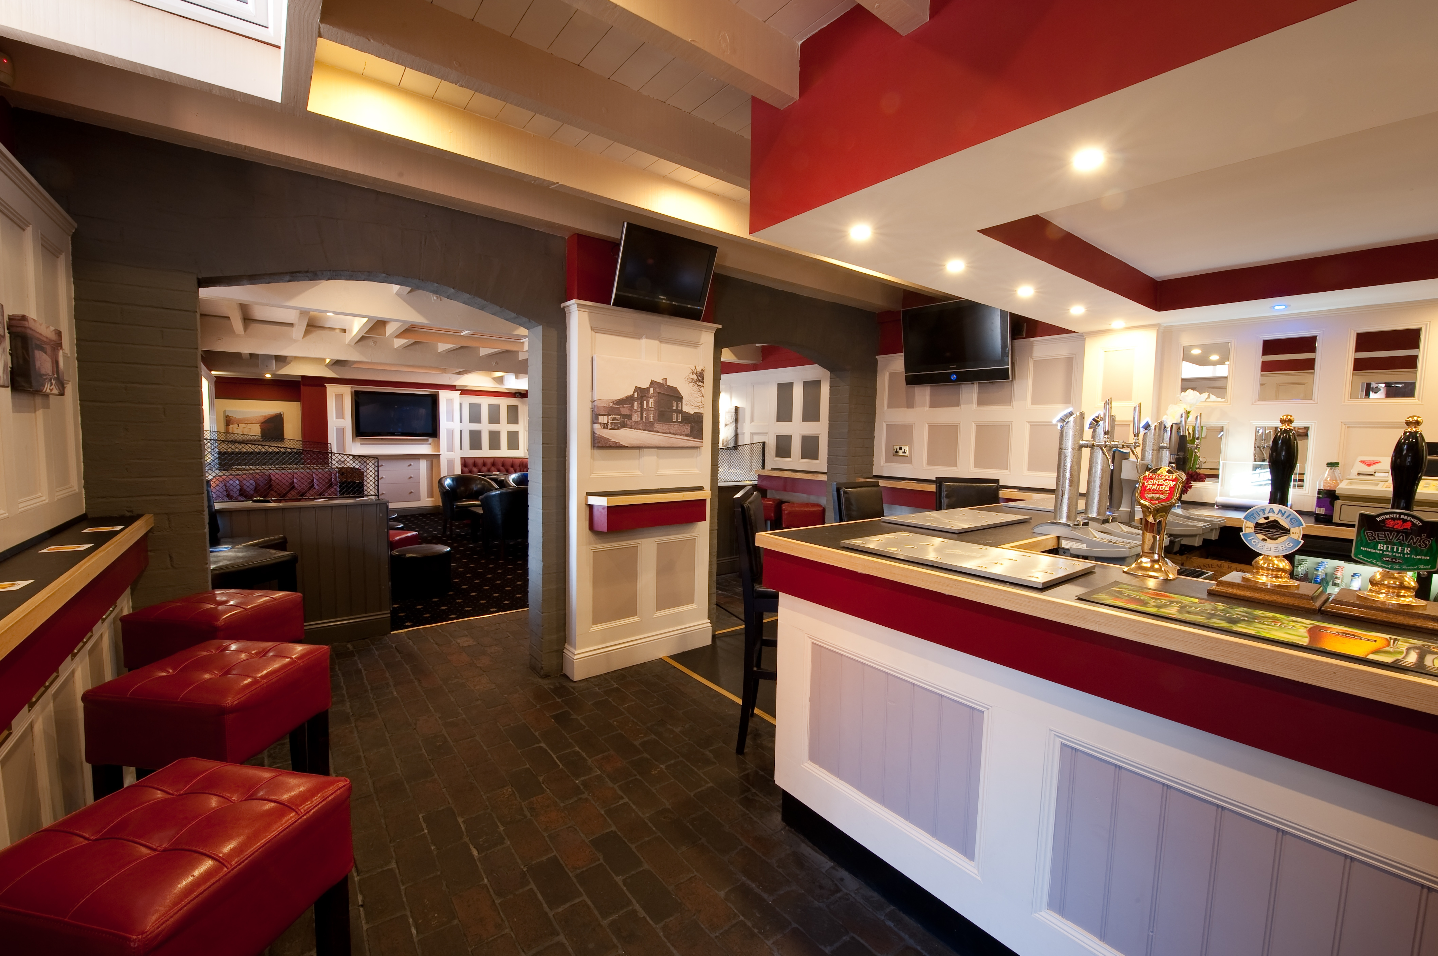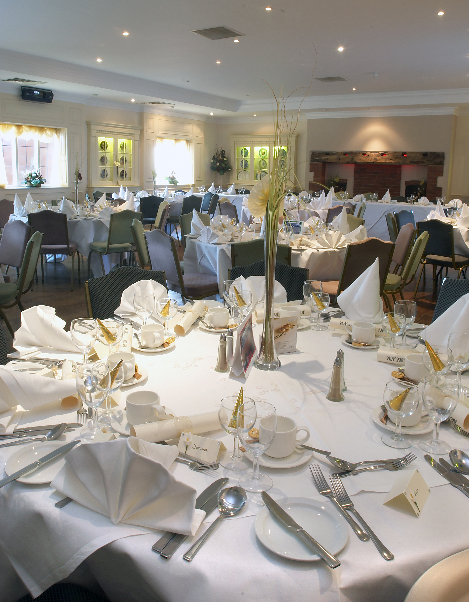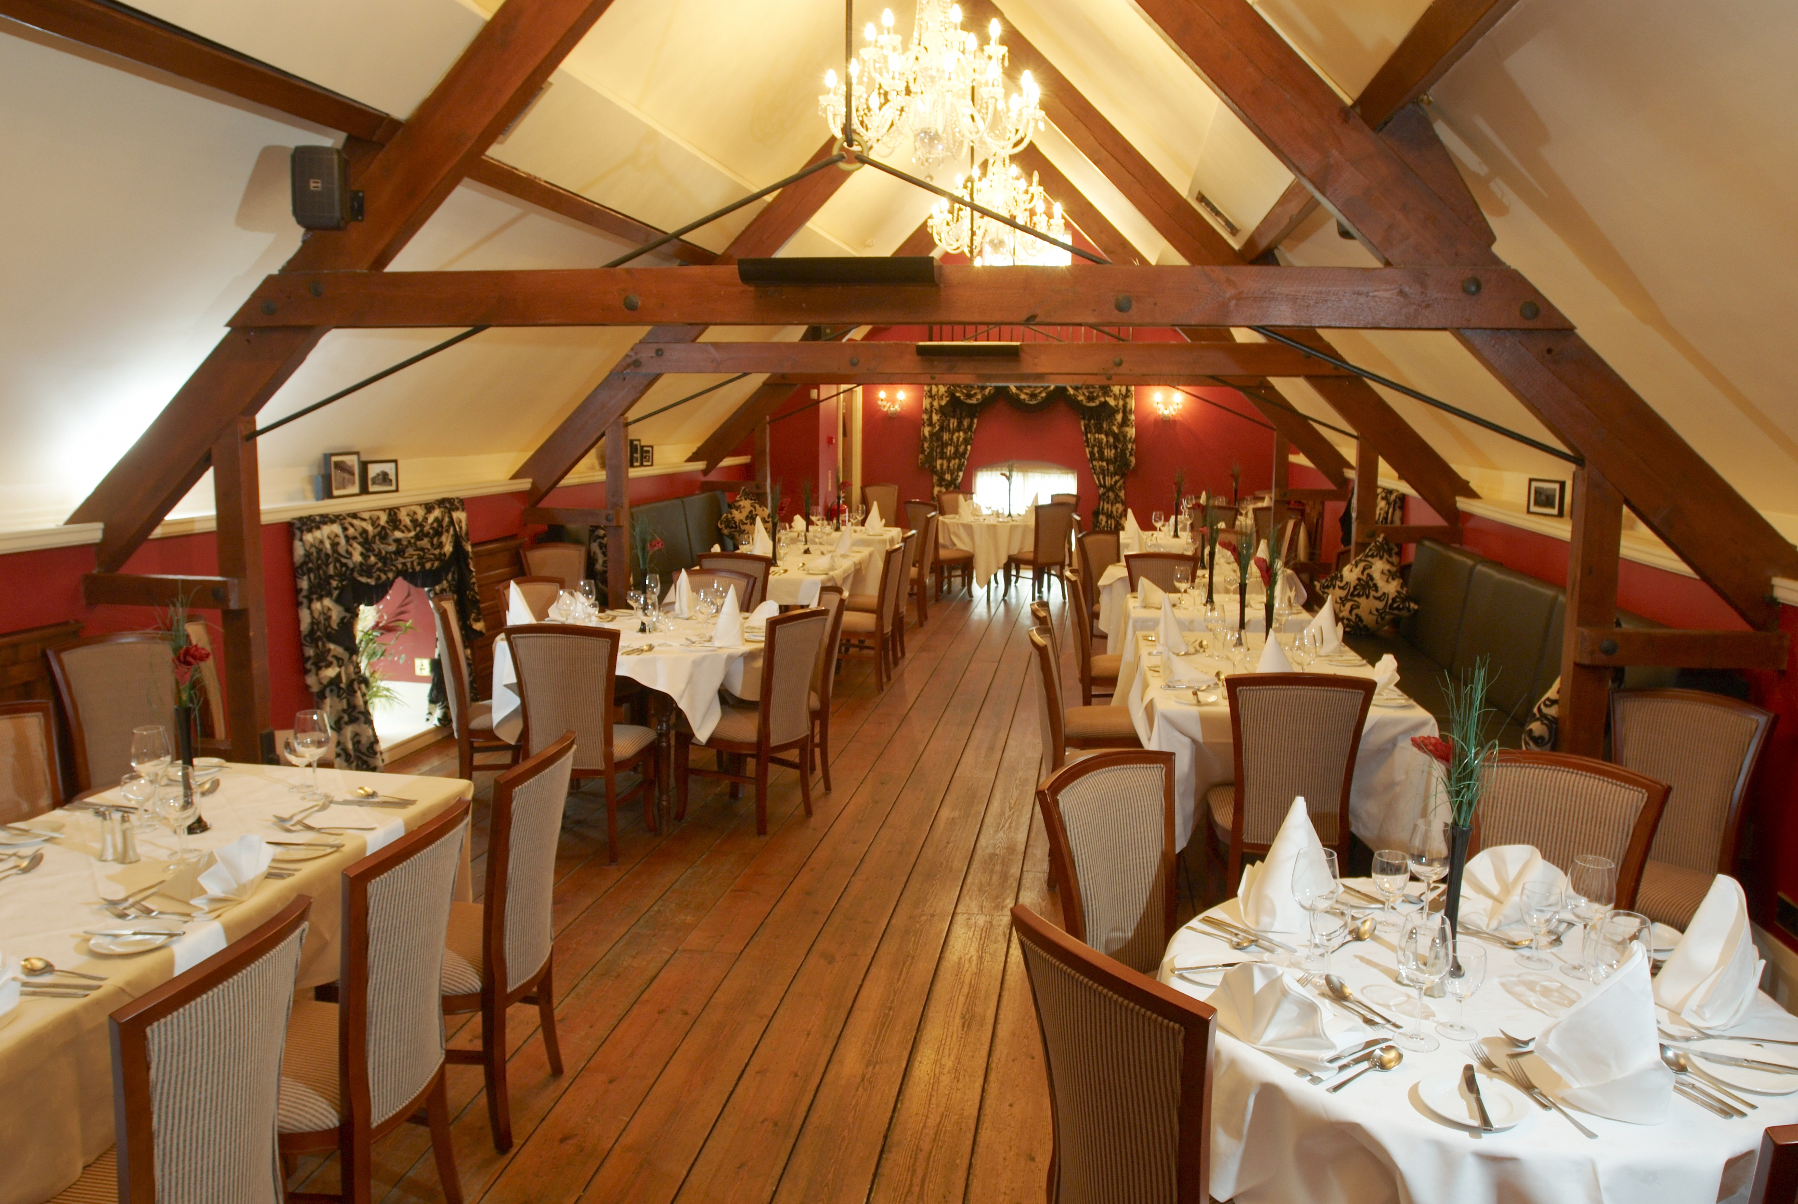

finger buffet £9.95
a selection of fresh sandwiches
homemade sausage rolls
homemade mediteranean vegetable quiche
traditional ascot pork pie
mini vegetable samosas ,mini vegetable spring rolls
marinated Greek lamb skewers
mini savoury eggs
pickled onions, green salad,
baby cherry tomatoes
sweet chilli dip and tzatziki sauce

afternoon buffet £12.95
sandwiches to include
smoked salmon & cucumber,
egg mayo with watercress,
honey roast ham, grated cheddar and tomato
scones with clotted cream and strawberry jam
lemon drizzle cake,
carrot cake
victoria sponge cake

farmhouse buffet £13.95
platters of roast turkey and roast ham
breaded chicken goujons with sweet & sour sauce
traditional indian vegetable samosa’s
mini vegetable spring rolls ,mini onion bhajee
home-made Meditteranean vegetable quiche
bowl of waldorf salad, bowl of mixed salad
bowl of home-made coleslaw
home-made chunky chips
bread rolls and butter

other options
home-made chunky chips 95p per head
unlimited tea/coffee 50p per head

selection of desserts £4.50ph
guests get to choose from chocolate fudge cake, tarte au citron
and forest fruit cheesecake

mini dessert selection £100 for 25 guests / £195 for 50 guests
handmade selection of chocolate & coffee eclairs
blackcurrant squares , apricot tartlets, raspberry tartlets, opera squares
pistachio squares, lemon & chocolate tartlets

