The Barns Hotel | Cocksparrow lane | Cannock | Staffordshire | WS12 4PB Tel. 01543 469191 | Fax. 01543 462552 | e info@thebarnshotel.co.uk
www.thebarnshotel.co.uk

conference details

within the barns is the farmhouse banqueting and conference suite the main room will accommodate up to 100 people theatre style.
a further 4 rooms are available which can be used either as syndicate rooms to the main room, or on an individual basis accommodating up to 10 people in a boardroom style. In addition our restaurant can accommodate meetings of up to 30

location
a mile from cannock, just off the A34
A34 100yards, A5 - 1.5 miles, M6 - 2 miles
car parking for 140 cars

facilities
pa system with radio microphones (main room only),
projectors & screens, flipcharts, tv and dvd player,
wireless broadband
additional equipment is available with advance notice at a supplement.

fully inclusive package £24.95 per head inc vat
Includes:
room hire
use of conference facilities and equipment
tea/coffee and biscuits on arrival, mid morning and afternoon
lunch to include the farmhouse buffet, desserts and drinks
(for meetings of 12 or less we can offer an hot meal option which delegates choose at the morning break and is served at a time to suit you)
mineral water & cordials available throughout the day
paper and pens.

standard package £18.95 per head inc VAT
~ includes:
room hire
use of conference facilities and equipment
tea and coffee throughout the day
finger buffet lunch and squash
mineral water

alternatively we can tailor the package to your requirements
separate room hire
function room £195 (half day £150)
restaurant £150 (half day £125)
boardrooms £95 (half day £65)

tea and coffee £1.50 per session per person
biscuits 50p per person per session
free flowing tea, coffee & biscuits £4.95 per head
bacon/sausage sandwich £3.95 per head
bottles of mineral water £2.95 each
mini Danish pastries £2.95 per person per session

buffets options(see attached menu’s)
£5.95 for sandwich selection and soup
£11.95 finger buffet
£14.95 farmhouse buffet

accounts
we offer invoice facilities on completion of a credit application form

accommodation
should you require accommodation for delegates /trainers we have 21 en-suite bedrooms on site with full bar and restaurant facilities

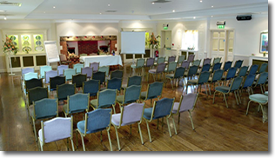
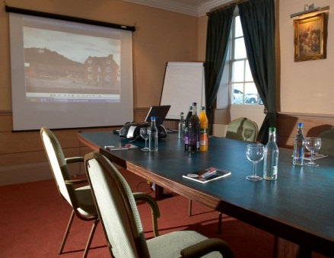
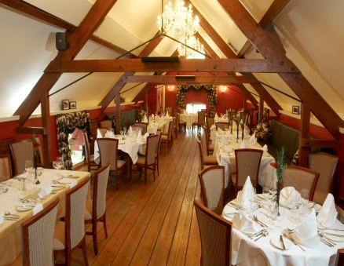

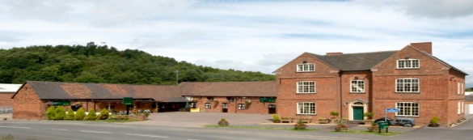

conference buffet menus

finger buffet £11.95
sample for standard package
dessert £4.50ph additional
a selection of fresh sandwiches
homemade sausage rolls
home-made mediterranean vegetable quiche
traditional ascot pork pie
mini indian vegetable samosas
mini vegetable spring rolls
mini savoury eggs, marinated lamb skewers
salad & dips

farmhouse buffet £14.95
served with fully inclusive package included desserts
platter of roast turkey and ham
traditional indian vegetable samosas
breaded chicken goujons with sweet & sour sauce
mini vegetable spring rolls
mini onion bhaji
bowl of waldorf salad
bowl of mixed salad
bowl of home-made coleslaw
home-made chunky chips
bread rolls and butter

conference hot buffet options £14.95
served with fully inclusive package includes desserts

2 choices + veg option, or if numbers over 35, 3 choices + veg option

homemade cottage pie, homemade chilli con carnie
homemade beef tomato and spinach lasagne
homemade steak and ale pie, chefs chicken balti
braised beef with red wine, mushrooms
homemade vegetable lasagne, chick pea and lentil curry

